**Requirement Documentation**

**In Scope**

* **Security Module -** It is capable of controlling the access in the system.
* **Create & Viewing ticket module -** This Create Ticket Module can create ticket that will be use for transaction with the company and View Ticket for clients which will able them to see the progress of the issue they sent.
* **Ticket Module –** This module enables the administrator and the users to view the open tickets, the assigned tickets, closed tickets and those that are pending. In this module where they make the progress of the tickets.
* **Settings Module –** This module is accessible only by the administrator. In this module the administrator can add, edit and delete status, severity and resolution.
* **Users Module –** This module is accessible only by the administrator. In this module the administrator can add, edit, and delete user accounts for the system. The administrator also can activate and de-activate the user accounts.

**System Design**

**Development Testing and Testing**

**Description of the Prototype**

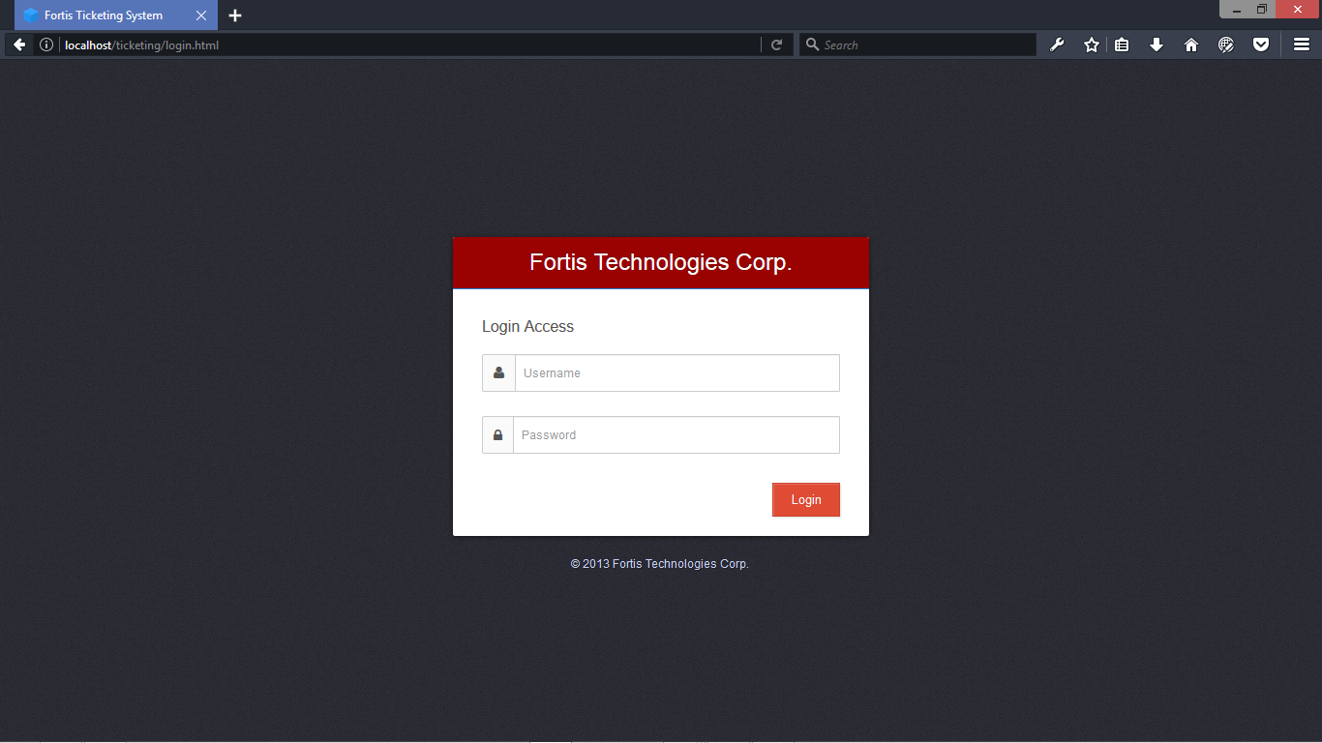

**Login Form -** This page is used to open a session with an account that is already created.

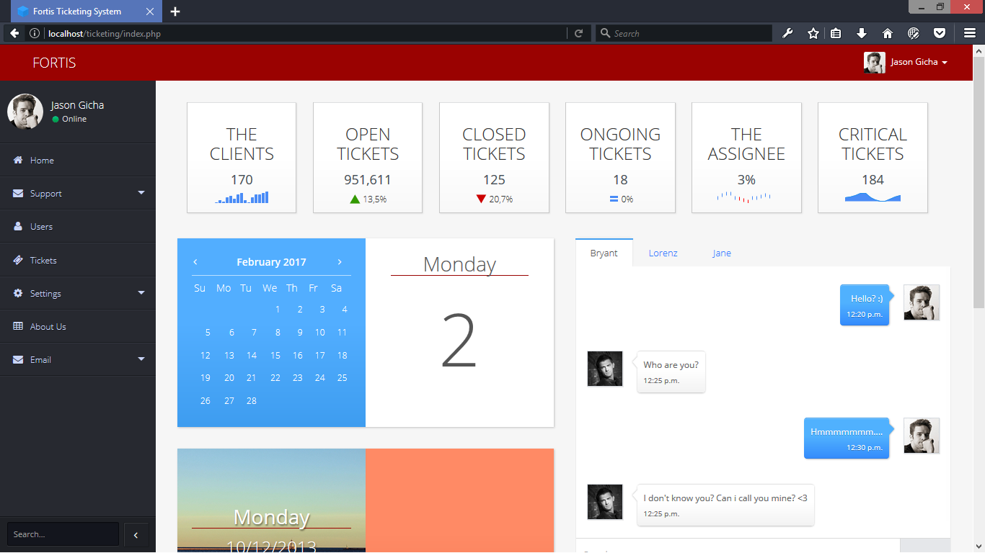

**Admin Index -**This Admin Index Module will use to see and to manage the system.

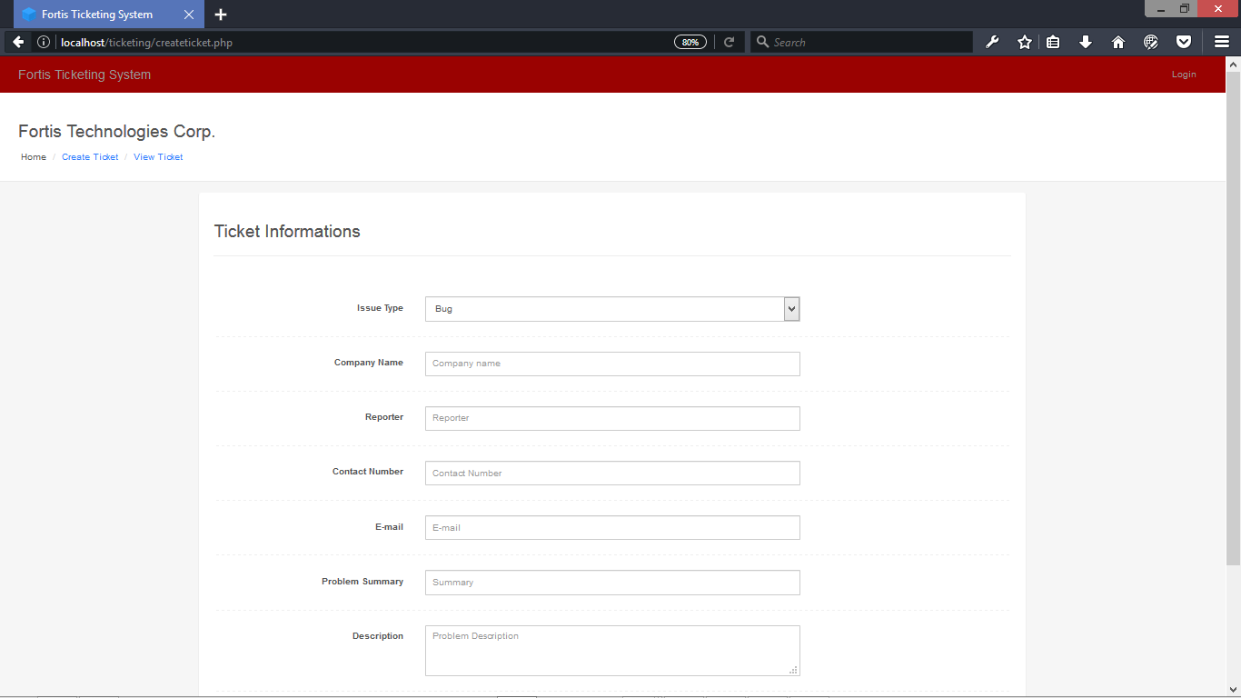

**Create Ticket -** This Create Ticket Module can create ticket that will be use for transaction with the company

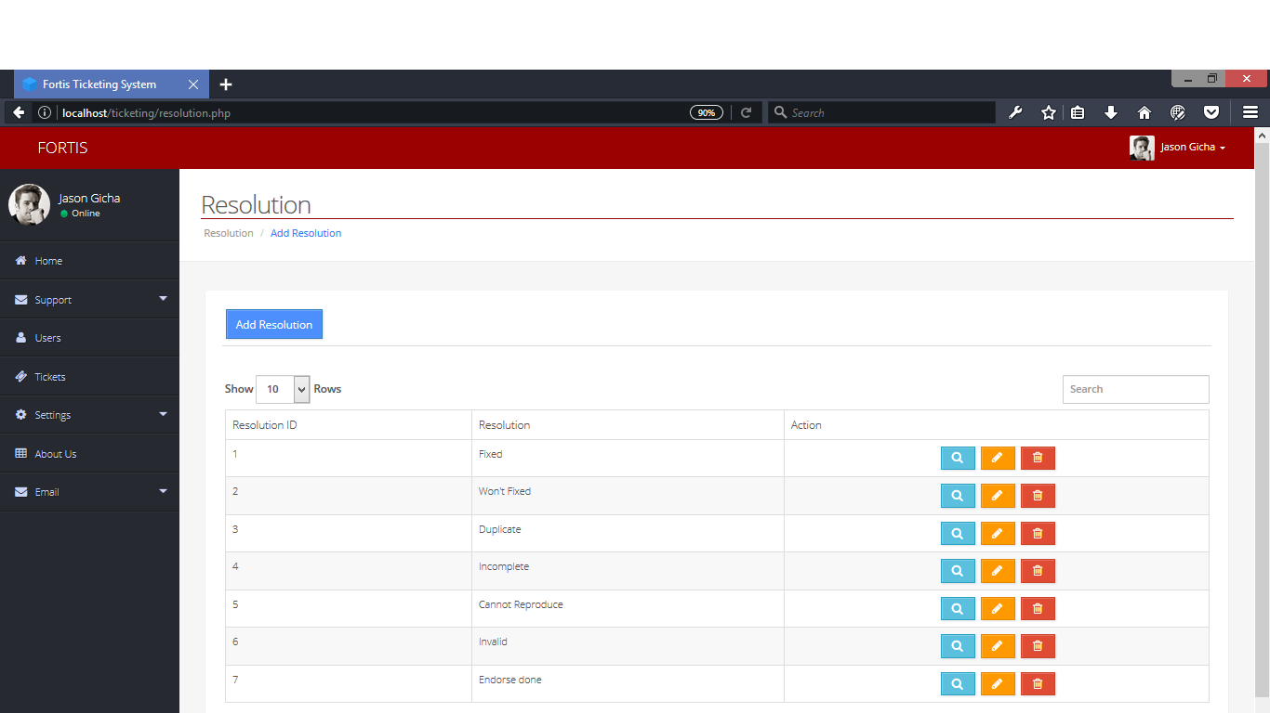

**Setting Resolution -** This Setting (Resolution) Module can add, edit, and delete resolutions.

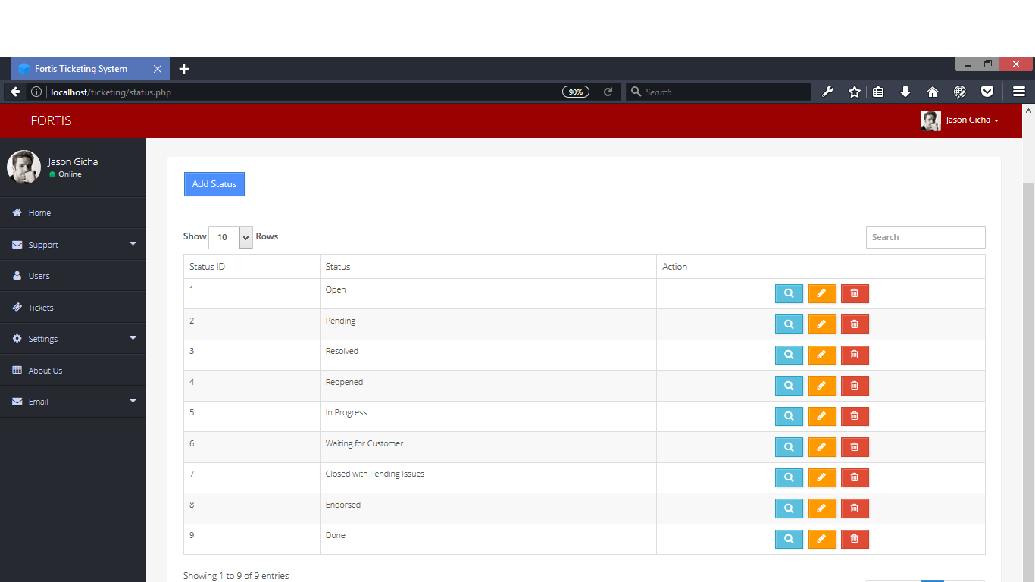

**Setting Status -** This Setting (Status) Module can add, edit, and delete status.

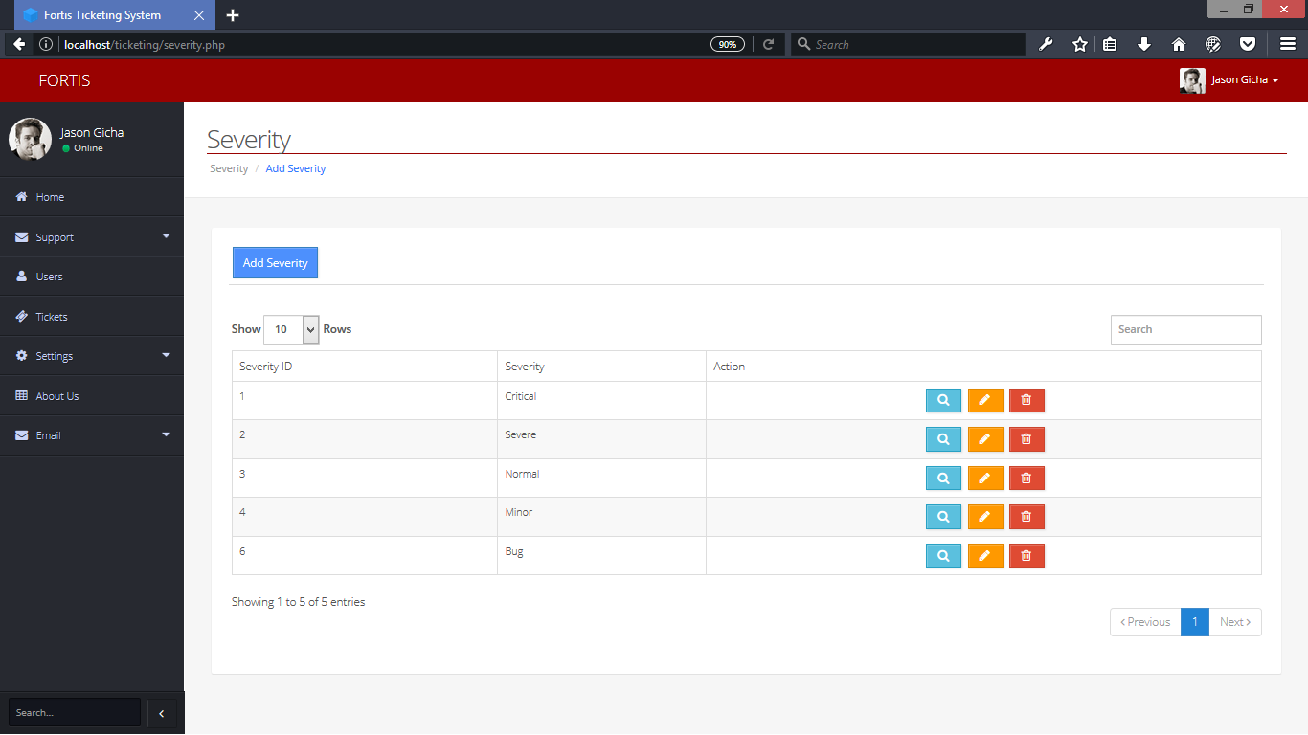

**Setting Severity -** This Setting (Severity) Module can add, edit, and delete severity.

**Implementation plan**